|  |  |
| --- | --- |
| **Experiment # 2** | |
| **Date of Performance:- 05/01/2023** | **Date of Submission:- 08/01/2023** |
| **Student SAP Id:- 70362019170** | |
| **Student Roll No:- E015** | |
| **Student Name:- Harshit Devadiga** | |

**Aim: - Design following –webpages using HTML…**

Create a static web pages using HTML

1. Create one HTML to interlink the webpages created in expt#1, use attributes link, alink and vlink for text hyperlinks.
2. Make use target attribute for the link (use values: self, blank)
3. Create link to section within same page (of your CV implemented in expt#1)
4. Use attribute type for lists in program 1 to change the type of sequence numbering & different symbols for unordered list.
5. Registration page (**Now, implement it using form tag**)
6. One web page with frames implemented (to display all three web pages implemented in expt #1) column-wise

**Note:- Don’t use any type of CSS in your code…**

**HTML Code 1 and 2 : -**

* **Code of interlink & target attribute**

**Interlink – (link, alink, vlink)**

<body link="blue" alink="green" vlink="red">

**Target attribute:**

    <p align="center">

      <a href="Home.html" target="_self" rel="noopener noreferrer">Home</a>

      &nbsp

      <a href="Registration.html" target="_blank" rel="noopener noreferrer"

        >Registration</a

      >

      &nbsp

      <a href="Contact Us.html" target="_blank" rel="noopener noreferrer"

        >Contact Us</a

      >

    </p>

**Output (only in print screen format) Code -1 & 2**

* **Output**

**link:**

**vlink:**

**alink:**



**HTML Code 3 ,4 and 5 : -**

* **Modified code of CV implemented in Expt#1**

**Button to Go Up:**

    <button>

      <a href="#nmims">Go Up</a>

    </button>

**Sequencing:**

**Unordered List:**

    <ul type="square">

      <li>

        <h4>

          Program 1: HTML, CSS, and Javascript for Web Developer, Angela yu

        </h4>

      </li>

      <li>

        <h4>Program 2: Python for everyone, Coursera</h4>

      </li>

    </ul>

**Ordered List :**

    <h3>TECHNICAL-PRESENTATION/WORKSHOPS/CERTIFICATION</h3>

    <ol type="i">

      <li>

        <h4>Django Internship at Infytech Bangalore, India</h4>

      </li>

      <li>

        <h4>Full Stack Web Development Intern at Directi, Bangalore</h4>

      </li>

    </ol>

**Output (only in print screen format) Code -3 to 5**

* **Output**

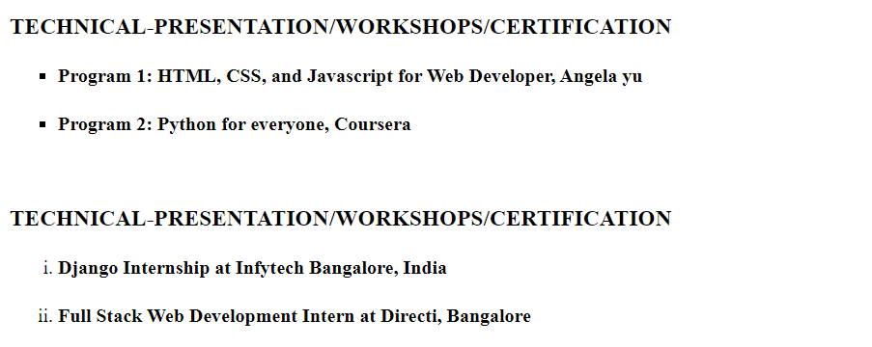



**HTML Code 6 : -**

* **Registration Form**
* <!DOCTYPE html>
* <html lang="en">
* <head>
* <meta charset="UTF-8" />
* <meta http-equiv="X-UA-Compatible" content="IE=edge" />
* <meta name="viewport" content="width=device-width, initial-scale=1.0" />
* <title>Registration Page</title>
* </head>
* <body>
* <div align="center">
* <table cellspacing="15">
* <tr>
* <td>
* <h2>
* <a href="Home.html" rel="noopener noreferrer">Home</a>
* </h2>
* </td>
* <td>
* <h2>
* <a
* href="Registration.html"
* target="_blank"
* rel="noopener noreferrer"
* vlink="red"
* >Registration Page</a
* >
* </h2>
* </td>
* <td>
* <h2>
* <a
* href="Contact Us.html"
* target="_blank"
* rel="noopener noreferrer"
* >Contact Us</a
* >
* </h2>
* </td>
* </tr>
* </table>
* </div>
* <div align="center">
* <img width="200" src="nmims.png" alt="" />
* </div>
* <form action="#">
* <table width="5%">
* <tr>
* <td>
* <label for="name">Username: </label>
* </td>
* <td>
* <input type="text" name="email" id="name" />
* </td>
* </tr>
* <tr>
* <td>
* <label for="uemail">Email: </label>
* </td>
* <td>
* <input type="email" name="username" id="uemail" />
* </td>
* </tr>
* <tr>
* <td>
* <label for="uage">Age: </label>
* </td>
* <td>
* <input type="text" name="userage" id="uage" />
* </td>
* </tr>
* <tr>
* <td>
* <label for="upassword">Password: </label>
* </td>
* <td>
* <input type="password" id="pass" name="upassword" />
* </td>
* </tr>
* <tr>
* <td>
* <label>Gender:</label>
* </td>
* <td>
* <label>
* <input type="radio" value="f" name="gender" /> Female</label
* >
* <label> <input value="m" type="radio" name="gender" /> Male</label>
* </td>
* </tr>
* <tr>
* <td><label for="udob">Date of Birth: </label></td>
* <td><input type="date" name="udob" /></td>
* </tr>
* <tr>
* <td><label for="salrange">Range of Salary:</label></td>
* <td><input type="range" name="salrange" /></td>
* </tr>
* <tr>
* <td>
* <label for="uprog">Employee Progress: </label>
* <br />
* <progress id="uprog" value="30" max="100"></progress>
* </td>
* </tr>
* <tr>
* <td><label for="uclour">Colour Picker: </label></td>
* </tr>
* <tr>
* <td><input type="color" name="uclour" id="clours" /></td>
* </tr>
* <td>
* <p>
* <label>
* Address :
* <br />
* <textarea name="address" cols="15" rows="12"></textarea>
* </label>
* </p>
* </td>
* <tr>
* <td>
* <label for="res">Resume:</label>
* <input type="file" id="res" />
* </td>
* </tr>
* <tr>
* <td>
* <label for="pet-select">Employee Role:</label>
* <select name="pets" id="pet-select">
* <option value="">--Please select an option--</option>
* <option value="Data Scientist">Data Scientist</option>
* <option value="Project Manager">Project Manager</option>
* <option value="Junior Software Developer">
* Junior Software Developer
* </option>
* <option value="Senior Software Developer">
* Senior Software Developer
* </option>
* </select>
* </td>
* </tr>
* <tr>
* <td>
* <input type="submit" value="Submit" />
* <input type="reset" name="" id="" />
* </td>
* </tr>
* </table>
* </form>
* </body>
* </html>

**Output (only in print screen format) Code -6**

* **Output**

**HTML Code 7 : -**

* **Frame**
* <!DOCTYPE html>
* <html lang="en">
* <head>
* <frameset cols="25%,*,25%">
* <frame src="Home.html">
* <frame src="Registration.html">
* <frame src="Contact Us.html">
* </frameset>
* <meta charset="UTF-8" />
* <meta http-equiv="X-UA-Compatible" content="IE=edge" />
* <meta name="viewport" content="width=device-width, initial-scale=1.0" />
* <title>Document</title>
* </head>
* <body>
* <h2>Frames</h2>
* </body>
* </html>

**Output (only in print screen format) Code -7**

* **Frame output**

**Observation and Learning: -**

* **Write your observation and learning**

**I learnt how to interlink webpages using alink, vlink and link attributes. I also learnt how to create a link to section within the same page, create forms in html, link all three pages in frames.html page, adding sequencing using ordered and unordered list.**

**Answer the Questions: -**

1. What is hyperlink in HTML? Which tag is used? What are various attributes of <a>? explain.

Ans:

A link is a chain that connects pages both within a website and to other websites. Without links, we wouldn't have any websites. <a> tag is used to implement hyperlinks in the html website. Different attributes of <a> tags are _blank, _self, href, media, ping.

1. What are various list tags?

Ans:

Various list tags are <ul>, <ol>, <li>, <dl>,<dt>.

1. What are various table tags?

Ans:

Some table tags are: <table>, <tr>, <td>, <th>.

1. List out various form elements and their associated tags.

Ans:

HTML form elements:

<input>, <label>, <select>,<textarea>,<button>,<fieldset>,<legend>, <datalist>, <output>, <option>, <optgroup>